**Track and Field 2018 Order Form**

Both the t-shirts and sweatshirts this year will be royal blue with white and black lettering. They will have different designs, but both say Wallkill Panthers Track and Field.

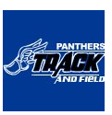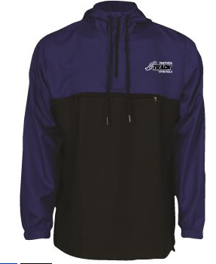**2018 Jackets!** The jackets are ¼ zip, royal blue and black, light weight, mesh lined, dobby poly, windproof and water resistant.

**COST:**

T-shirt: $10

Sweatshirt: $20

Pullover: $45

**We will only be accepting checks and orders in a sealed envelope with your name on the front.**

All orders are to be turned in to Coach Kennedy by March 17, 2018.

Name: ______________________________

|  |  |  |  |  |  |
| --- | --- | --- | --- | --- | --- |
| Item | Small | Medium | Large | X-Large | Total |
| T-shirt |  |  |  |  |  |
| Sweatshirt |  |  |  |  |  |
| Pullover |  |  |  |  |  |

Total Amount Enclosed: ____________

Check #: __________